REPORT ON YOLOV7 MODEL TRAINING AND TESTING
Introduction
As we know about yolov model that is object detection model. So yolov7 is a member of this family with some advanced feature from its previous versions. Basic overview of the yolov model is the image frame feature through backbone, they are combined and mixed and then they are passed to head of he network, and yolov predicts the locations and classes of objects around which bounding boxes should be drawn. It is improved version of yolov5 and yolov6 in terms of accuracy, faster inference, better small object detection and more stable training. There is more about the model……
Dataset
The Dataset which I have used in this model training
Name - Road Damage det
Source – Roboflow
URL - https://universe.roboflow.com/baka-1ravj/road-damage-det/dataset/4/download/yolov7pytorch
Download Format: YOLOv7 PyTorch TXT
Images – 10,000
Classes(6 different type of damage) - alligator cracking, edge cracking, longitudinal cracking, patching, rutting, and transverse cracking
Dataset Structure –
/train ( training dataset contain 70% of images with labels )
/valid ( validation folder contains 20% of images with labels )
/test ( about 10% of the dataset is for testing for final evaluation )
data.yaml
README.roboflow.txt
README.dataset.txt

Training
About training I used about 20 epochs , batch of 16 , with a workloader of 4, on a GPU it took about 1 to 1:15 hour to train.
It was more difficult to train on higher epoch and on CPU, on CPU (it was showing about 7 to 10 hour for the training of the model with only 50 epoch.
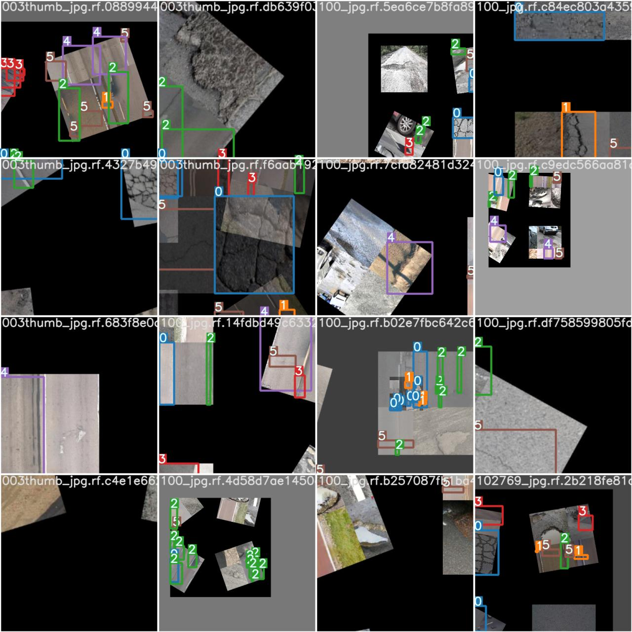
Fig. train_batch0
This is image of training you can see the bounding boxes demonstrating the class of the damage.
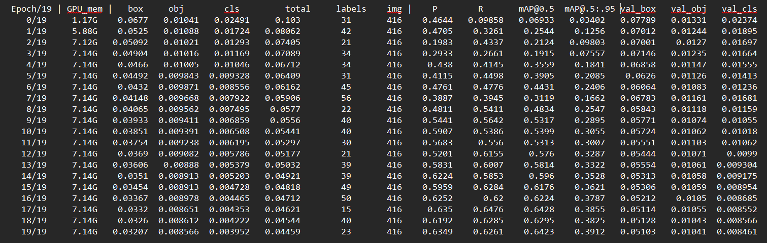
Fig.results.txt
This is the result of each epoch with all the parameters including accuracy, recall, precision, etc…..
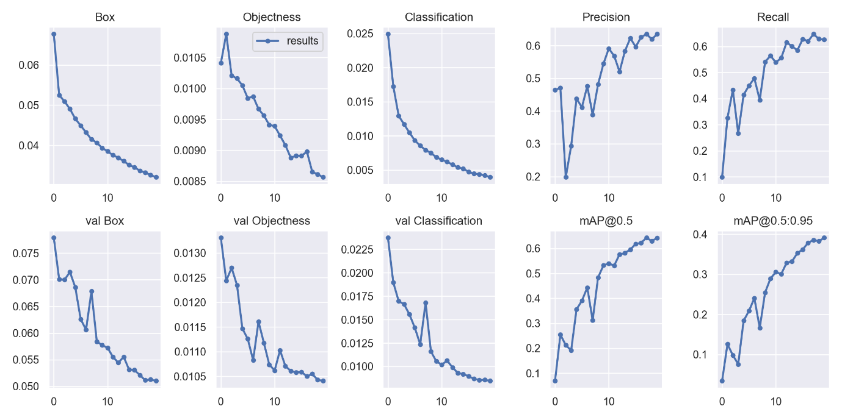
Fig.result_graph
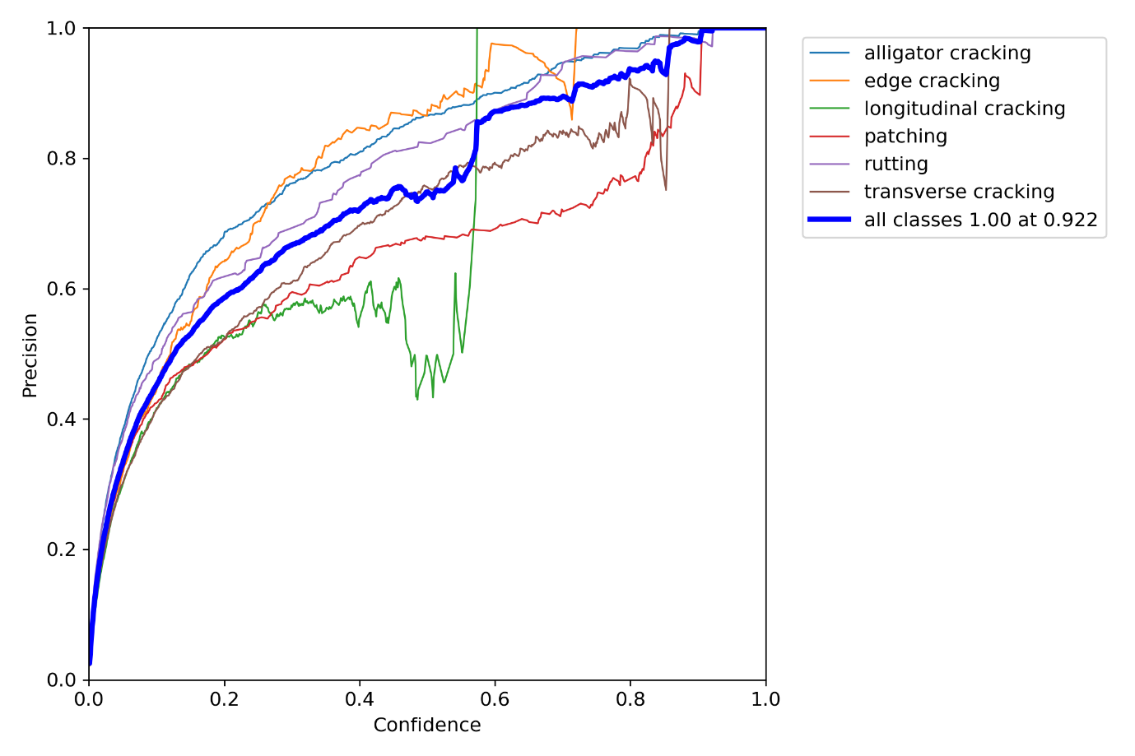
Fig.precision_curve
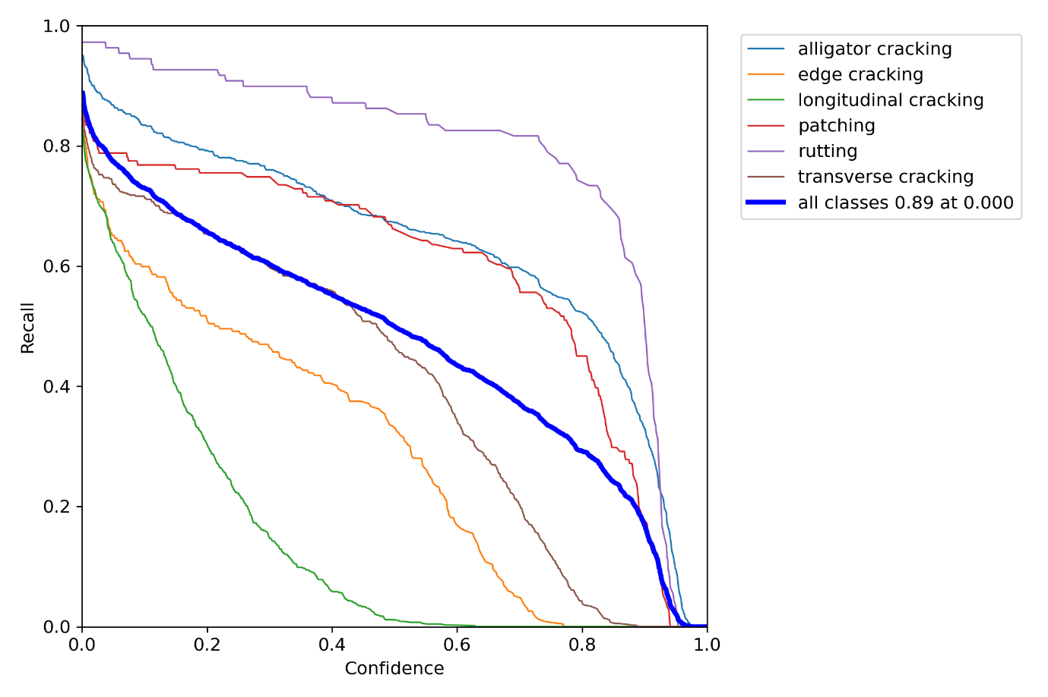
Fig. recall_curve

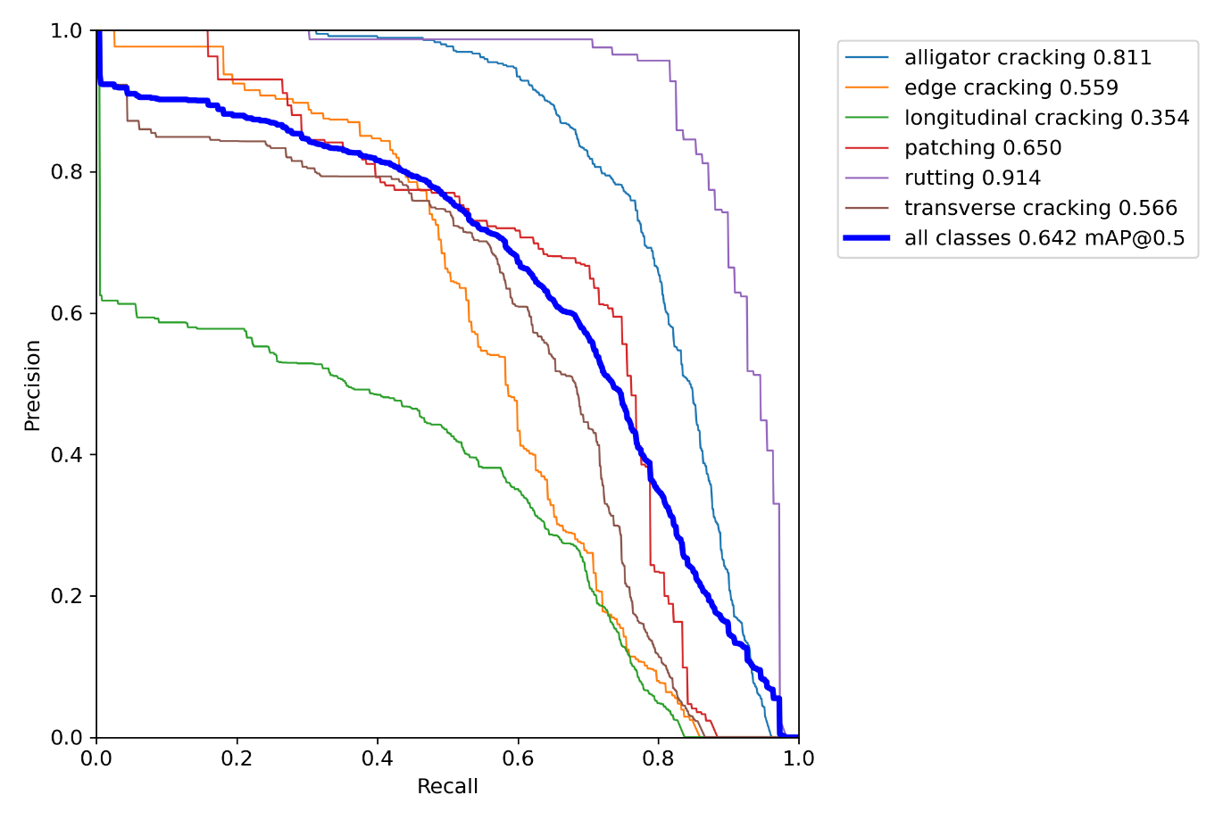
Fig. precision_recall_curve

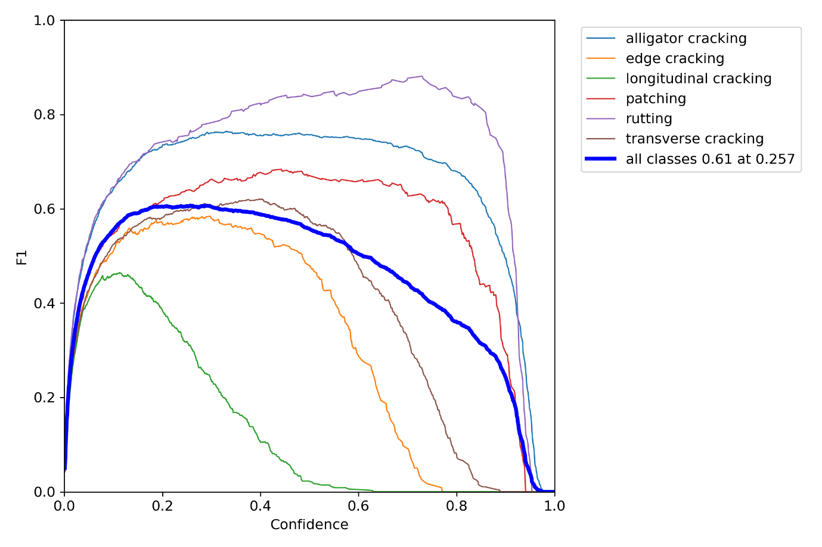
Fig. F1_curve
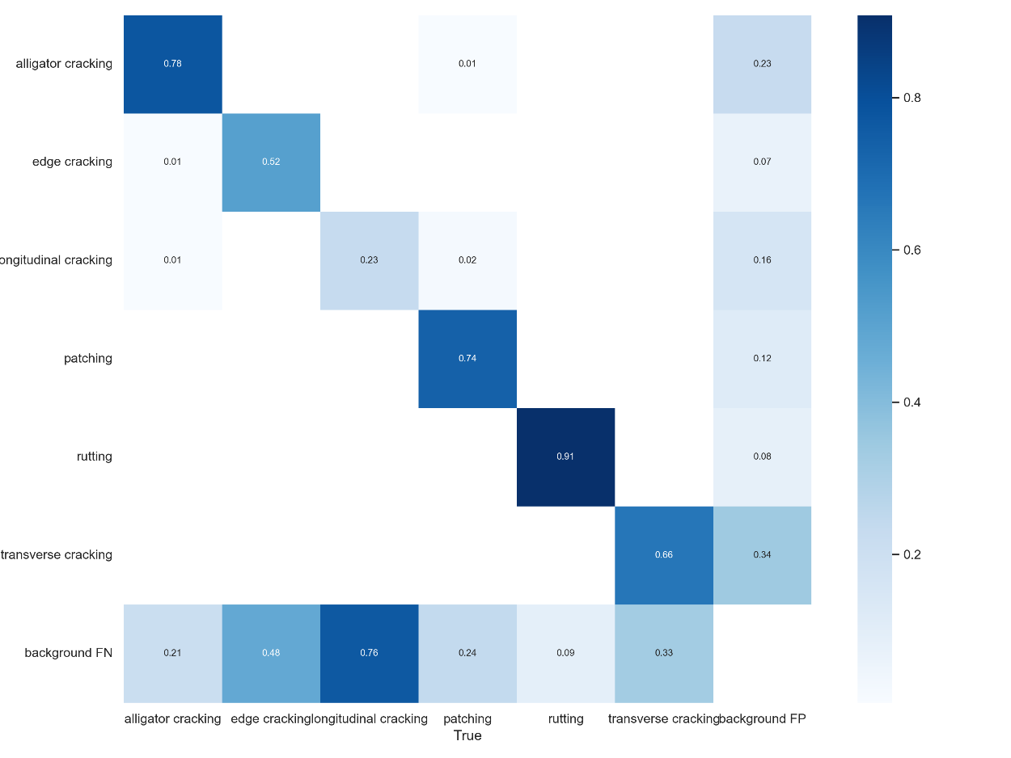
Fig. confusion_matrix
Training the yolov7 model with high epoch and batches may consume a lot of time, and if the epochs are greater than accuracy can also increase with respect it, but the computation becomes more.

Testing
After training testing is done for checking whether the model can work properly on unknown data.

Fig. precision
Fig. recall
Fig. precision vs recall

Fig. F1 score
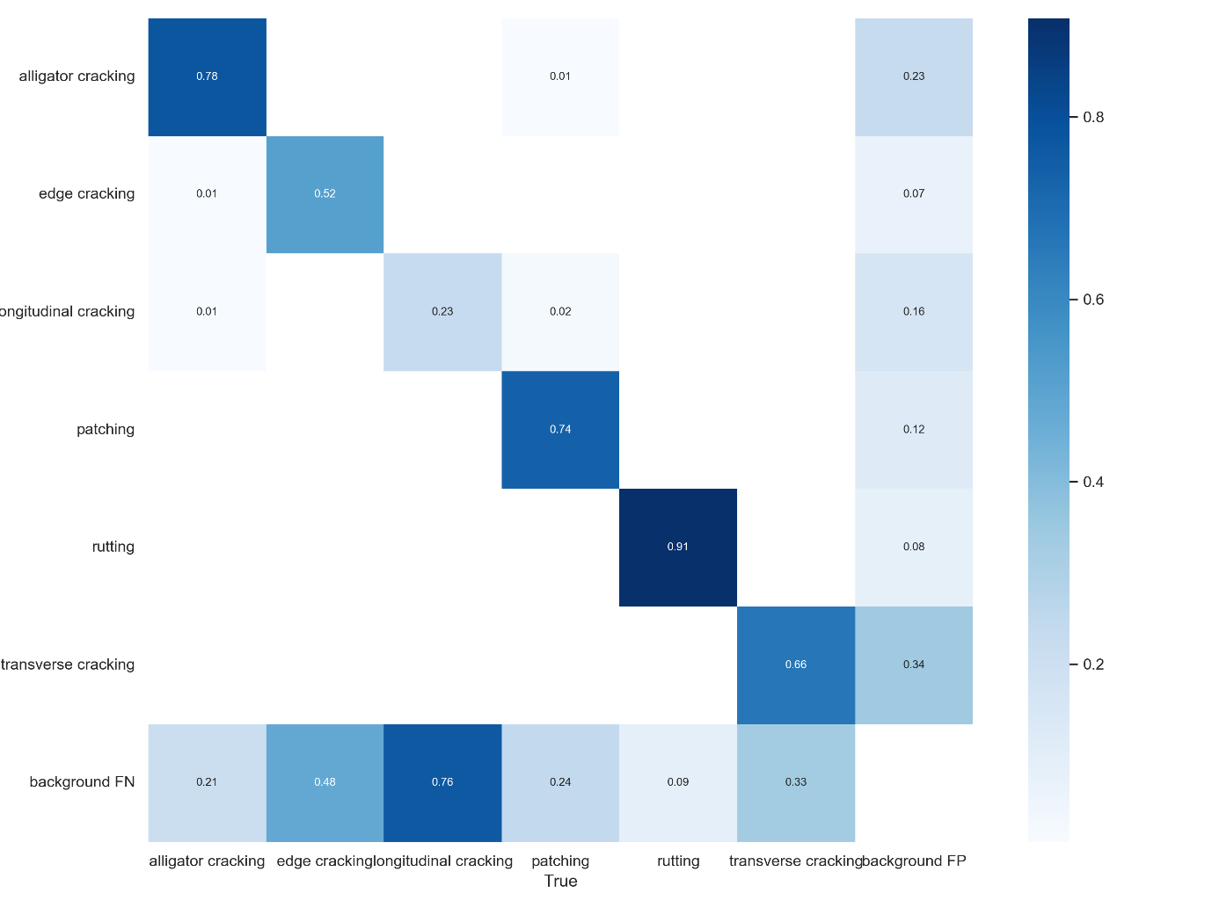
Fig.confusion metric

Final result :
Metric | Value
Precision | 0.6349
Recall | 0.6261
F1-Score | 0.6304
mAP@0.5 | 0.6423
mAP@0.5:0.95 | 0.3912
The model's accuracy is relatively low because road damage detection is a highly challenging task. Crack categories such as longitudinal, edge, and transverse cracking are very thin, low-contrast, and visually similar to shadows and road textures. The dataset is imbalanced and contains significant noise. Additionally, training was performed for only 20 epochs, which is not enough for complex crack detection tasks. YOLOv7 generally requires 50–150 epochs for optimal results.

Conclusion
In this project, the YOLOv7 model was successfully trained and evaluated on the Road Damage Detection dataset obtained from Roboflow. The model achieved promising results, with a precision of 0.6349, recall of 0.6261, and an F1-score of 0.6304. The overall mAP@0.5 of 0.6423 indicates that YOLOv7 can reliably detect most types of road surface damage. However, the lower mAP@0.5:0.95 score (0.3912) highlights the difficulty of predicting precise bounding boxes for thin, irregular cracks such as longitudinal and edge cracking. These damages are naturally challenging due to their small size, low contrast, and similarity to road textures.
The analysis of the confusion matrix further shows that classes like rutting, patching, and alligator cracking were learned well by the model, while thin crack types were less accurately detected. This performance is partly limited by the challenging nature of the dataset, the presence of shadows and noise, class imbalance, and the relatively short training duration of 20 epochs.
Despite these limitations, YOLOv7 demonstrated good generalization across training, validation, and test datasets, proving its effectiveness for automated road damage detection. With additional training epochs, improved augmentations, balanced datasets, and higher-resolution inputs, the accuracy of the model can be significantly enhanced. Future work may also explore improved variants such as YOLOv7-X or YOLOv8, and deploying the model for real-time inspection on actual road environments.
Overall, the project successfully demonstrates that YOLOv7 is a strong candidate for real-time, automated road damage detection and has substantial potential for aiding infrastructure monitoring and maintenance systems.

